**Call Centre Trends: Visualising customer and agent behavior.**

*A Case Study from PwC Switzerland: Power BI Virtual Experience*

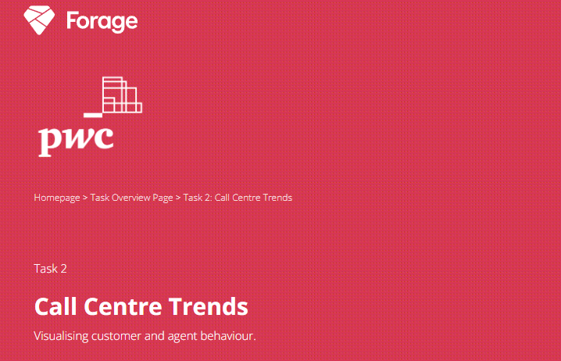

The digital revolution and our fast-changing world require a skills revolution. And it’s not just about digital skills. The skills revolution is about helping people build their digital awareness, emotional intelligence, and creativity to fully participate in the digital future workplace

**TASK**

It’s omnipresent: telecom marketing. Better price here. Better service there. Best for small businesses here. Best for young urbanites there. But what do customers really want? Our client, a big telecom company needs to know. This email just arrived for you: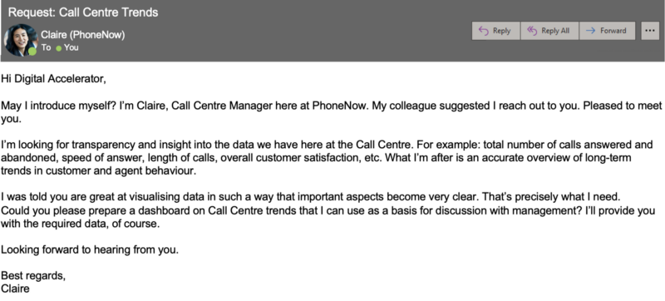

Create a dashboard in Power BI for Claire that reflects all relevant Key Performance Indicators (KPIs) and metrics in the dataset. Get creative!

**Possible KPIs include (to get you started, but not limited to):**

* Overall customer satisfaction
* Overall calls answered/abandoned
* Calls by time
* The average speed of answer
* Agent’s performance quadrant -> average handle time (talk duration) vs calls answered

**PROCESS**

First, import the data to Power BI. Before we load the data, we need to make sure that the data is clean. Click Transform Data.

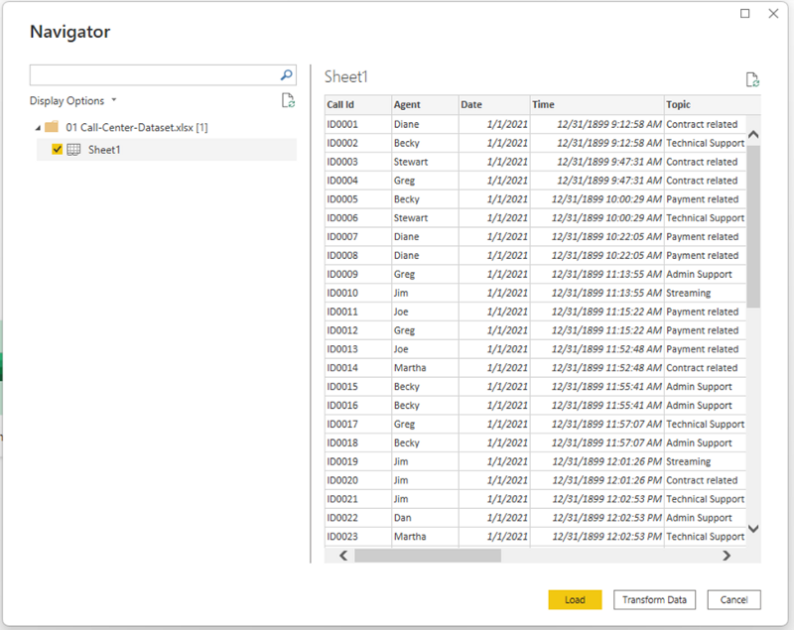

I noticed that there are a lot of null values for the *speed of answer in seconds* column, so I filtered to only show the null values and observed the data. As I can see in the filtered data, all calls were not answered therefore having null values for the average talk duration is valid. I didn’t change the null values to 0 because if the agent failed to answer the call, then there shouldn’t be any values for average talk duration and satisfaction rating. Making it zero will affect their KPI.

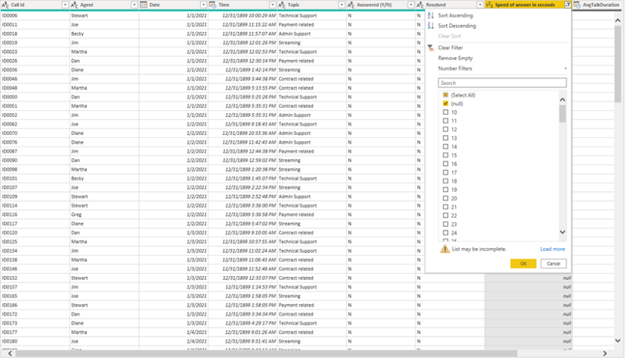

I noticed the *AvgTalkDuration* column is in Date/Time format which should be in duration. Change the data type to Time only, and then I added a new custom column and then subtracted *AvgTalkDuration* column by 00:00:00.

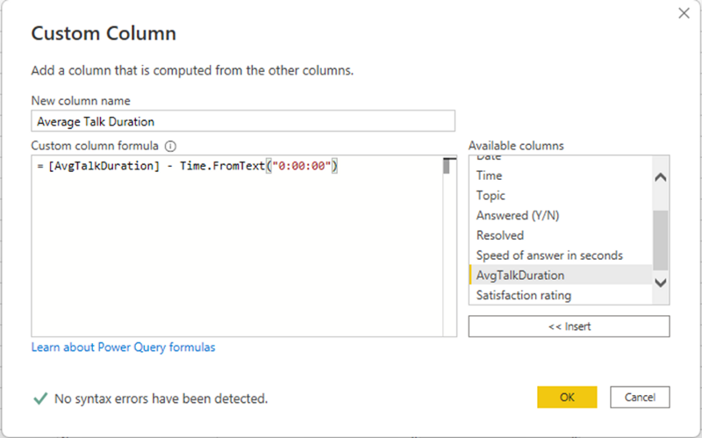

I renamed the new column to *Average Talk Duration* and changed the data type to duration and then show only seconds. The time column has date values in it, so I changed the data type to Time only.

**ANALYZE**

I have created measures to answer the questions and provide the following KPIs:

* Positive Satisfaction Rating

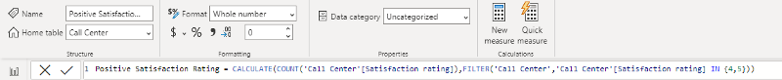

* Number of Satisfaction Rating

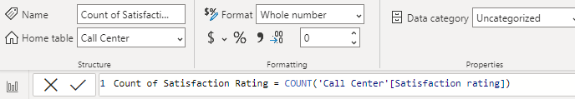

* Total Calls Answered

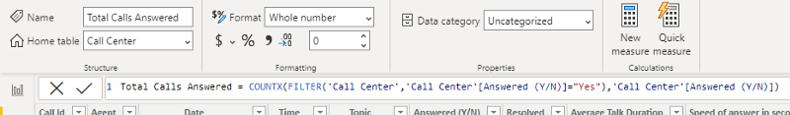

* Total Calls Abandoned

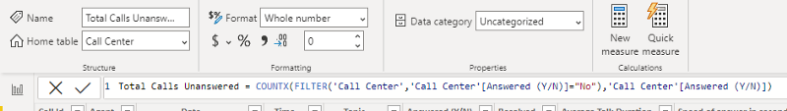

* Overall Customer Satisfaction

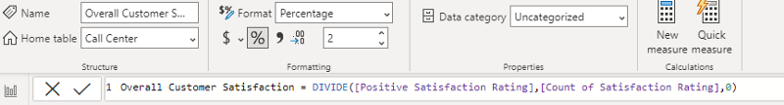

* Overall calls answered/abandoned

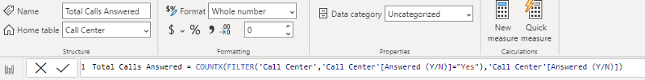

* Average speed of Answer

I inserted a card and then added *speed of answer in seconds* column and then chose average.

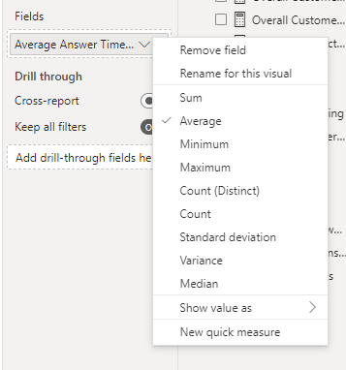

After getting all the required measures, I added cards in my dashboard to show all the KPIs at the top.



Next, I created a bar chart to show the average talk duration of agents. Dan has the longest talk duration and Greg is the fastest.

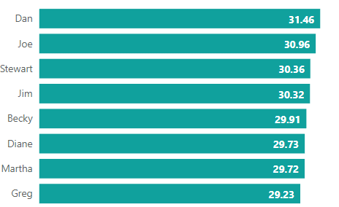

Then, I created a column chart that shows the average resolved calls per day of the week. It shows that every Monday and Saturday, agents have higher resolved calls than the rest of the day of the week.

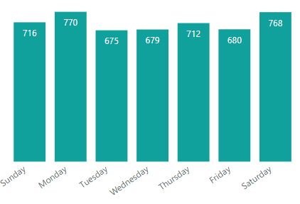

To summarize all the stats of the agents, I decided to insert a table that will show their total calls, answered calls, abandoned calls, resolved calls, unresolved calls, and satisfaction ratings.

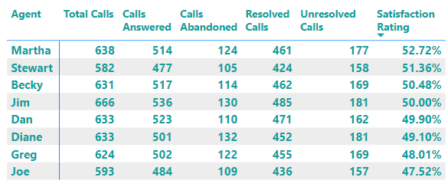

The last visualization is a treemap showing all the call topics.

Finally, I designed the dashboard and created the background using PowerPoint. Here is the final result:

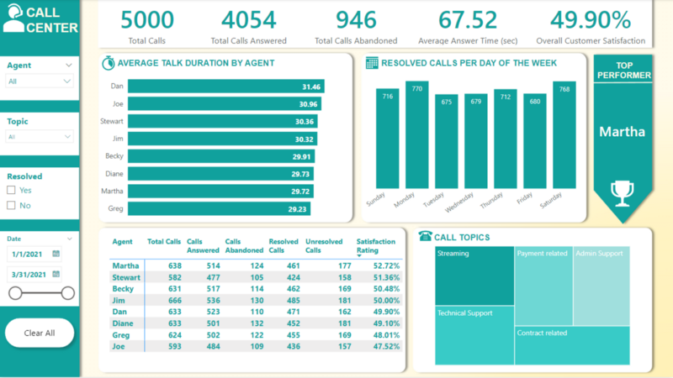

**INSIGHTS**

Based on the analysis, it appears that this call center has a relatively high rate of abandoned calls and a low overall satisfaction rating. This suggests that there may be issues with the call center’s ability to handle the volume of calls it receives, as well as potential problems with the quality of service provided to customers. Improving the call center’s answer rate and average response time, as well as increasing customer satisfaction, may be necessary to ensure the success of the business.

**RECOMMENDATIONS**

1. Identify and address the root cause of the high rate of abandoned calls. This could be due to a variety of factors, such as long wait times, complicated issues, or a lack of available agents. Once the underlying issue has been identified, steps can be taken to improve the call center’s performance.
2. Increase the number of available agents to handle the volume of calls. This could involve hiring additional agents, implementing a system for routing calls to multiple call centers, or utilizing technology such as virtual agents or chatbots to assist with customer inquiries.
3. Improve the call center’s average response time. This could be achieved through training and coaching for agents, implementing more efficient processes and technologies, or increasing the number of available agents to reduce wait times for customers.
4. Focus on increasing customer satisfaction. This could involve regularly surveying customers to gather feedback and identify areas for improvement, implementing customer service best practices, and providing ongoing training and support for call center agents.
5. Consider implementing a call-back system for abandoned calls. This could allow customers who are unable to wait on hold to leave their contact information and request a call back at a more convenient time. This could help to reduce the number of abandoned calls and improve the overall customer experience.